ANYBODY WISHING TO RECIEVE EASTER & SUMMER CAMP WORK MUST HAVE COMPLETED FOUNDATION, CHILD PROTECTION COURSE & GARDA VETTED

Personal details
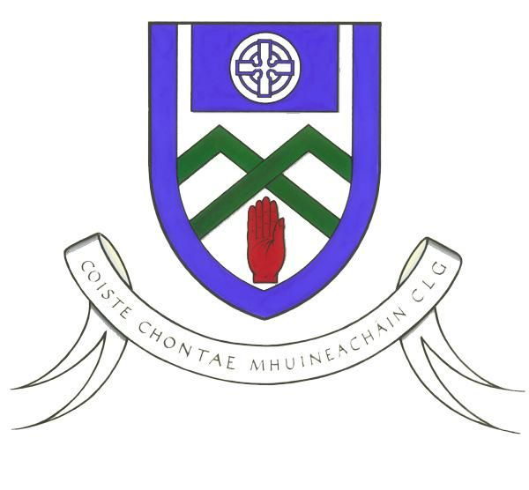

MONAGHAN

Easter & Kelloggs GAA

Cul Camps
COACHES Application Form

- Name: _____________________________
- Address:_____________________________ Club:___________________________________
- Date of Birth: ________________________ Age: ___ (Must be 18 or over to be a coach)
- Football____⁭ Hurling_____ ⁭ Both ______ ⁭
(Please tick as appropriate sport you would prefer / are qualified to coach)

Contact information

Mobile: _______________E-mail: ____________________________

Education; (Currently studying at what level please tick)
- Secondary School - Junior Certificate _____ Leaving Certificate _____

- Third level
If ticked this box please indicate:

What College: ___________________ What Course: _______________________

If not at college please state;
Your occupation: ______________________________________________

Current Employment Status: __________________________________ PPS No.______________

'If unemployed please state whether on UA, UB, Disability or other - specify' _____________.

If on UA, UB, Disability or Other, when you are working on the camps will you be coming off one of these Social Welfare Schemes? Yes __ No __

Coaching Information
- Qualifications: Please Provide Copies of Qualifications. N.B. Updated certs MUST be provided to be considered for position!!

GAA Qualification | GAA Safeguarding Child Protection | Garda Vetted
Please Circle;  Foundation Award  Award 1  Award 2  None of above  State year,month,venue you completed course below;  Year:  Month:  Venue: | Date completed:  Venue:  Cert No. | Please Circle:  Yes  No  If NO please apply ASAP.  If YES, state your garda reference number.
If you have none of the above but still interested in working on our camps, we will organise an Foundation Course. So please proceed with your application form if you wish to work on the camps.

Availability to work:

MONAGHAN

Easter & Kelloggs GAA

Cul Camps
Coaches
Application Form

Coaches will be expected to be available to work at each week of the camps.
Coaches must attend the full week of each camp. Changes by you to the committed weeks of work will not be accepted.

Please indicate if you are available to work on; Please circle..
Easter Camps
Cul Camps
Both

Easter Camps 2020
Venues | Dates | Time | Age Group | Price
Ballybay | 14th to 16th April | 10 – 2:30pm | 5 – 12-Year-Old Boys & Girls | 40 for 1st child & 35 for additional children
Scotstown
Clones

Please can you state that you can attend the Easter Camp Coaches Training Day on Saturday 4th April : YES___ NO _____

Monaghan Cul Camps 2020
Week 1 | Week 2 | Week 3 | Week 4 | Week 5
29th June – 3rd July | 6th – 10th July | 13th – 17th July | 20th – 24th July | 27th to 31st July
Clontibret | Castleblayney | Truagh | Donaghmoyne | Corduff
Clones | Monaghan Harps | Killanny | Magheracloone | Inniskeen
Carrickmacross | Emyvale | Ballybay | Scotstown | Eire Og
 |  | Aghabog |  | Latton

Please can you state that you can attend the Cul Camp Coaches Training Days on the 11th & 12th June: YES___ NO _____

Please return Application Form for EASTER & CUL CAMPS by; Friday 20th March.

ANYBODY WISHING TO RECIEVE EASTER & SUMMER CAMP WORK WILL HAVE TO UNDERTAKE A PRACTICAL ASSESSMENT & ATTEND INSERVICE TRAINING PROGRAMME

To: Paul O’Connor
Games Development Manager. 086-8374827
developmentmanager.monaghan@gaa.ie

