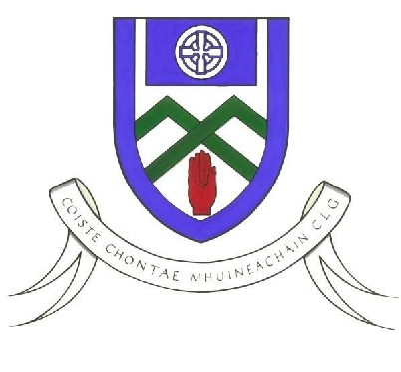
Cumann Luthchleas Gael
Coiste Chontae Mhuineachain
County Training Grounds, Cloghan, Annyalla, Castleblayney, Co. Monaghan
Monaghan GAA Football 5th Class After School South Programme 2019

To Parent / Guardian,

Monaghan GAA Coaching & Games realise the importance of player development and providing pathways for young players so that they can reach their full potential. For the past 8 years Monaghan Coaching staff organised an After School programme for players who are entering their last year in primary school. For this coaching block we will be focusing on 5th class. This is a Gaelic Skills Development Programme designed to improve those players who would like to take part in the programme.

The county has been divided into 4 regions (North, South, Mid & West). Each region will have a combination of large and smaller schools. The venue for the South programme is Patrician High School, Carrickmacross. This programme will run from 4:15pm – 5:45pm. Each region will receive a 4 week coaching block.

If your son is interested in participating in the South REGION Programme which commences on Thursday 17th January, please fill in the information below and get it back to me (see address below) before Monday 14th January. An e-mail will then be emailed out to you to confirm your son is attending. The e-mail will inform you of the day, time and venue of the programme.

This programme will cost €10 for the 4 weeks. Please bring on 1st day. Your child will receive a t-shirt on the last week.

This Coaching block will be led by Rory Beggan. He is fully qualified and Garda Vetted.

PLAYER NAME | CLUB | SCHOOL | DOB | Parent/Guardian  Number | Parent/Guardian  Name

E-Mail Address
Hoodie Size | 9-11 12-13 S M

If you have any questions, please contact Rory Beggan as soon as possible. His contact details are listed below.
Yours in GAA,

Rory Beggan
Address: Entekra Centre of Excellence, Cloghan, Annyalla, Castleblayney, Co. Monaghan
Mobile; 087 3528274
Email; rory.beggan.gda.monaghan@gaa.ie

