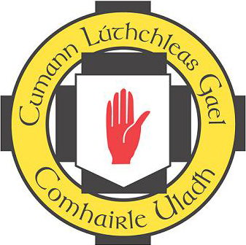
Cumann Lúthcleas Gael

Comhairle Uladh
8-10 Sráid an Mhargaidh
Ard Mhacha
Co Ard Mhacha
IARRATAS CLUICHE DÚSHLÁNA
(Challenge Match Application)
IARRATAS (Application) – to be completed by club
Club ………………………………

Contae ………… ……………………..

We, the undersigned, wish to make application to Comhairle Uladh, as required by Rule 6.39 (a) for permission to organise a challenge match, as outlined below:

----------------------------------------- v ------------------------------------------

Code: Football

Has your County Committee given permission: *Yes
Grad: Senior
Data ……/…../….

Ionad …………..……… ………………

Reiteoir (If known at this stage) ……………………..…………….
Reiteoir Status*:

Rúnaí …………………………… ………….……………......

* Delete as appropriate

Note: This Challenge Match application form is to be completed by Club and forwarded to County Secretary who will then forward to Comhairle Uladh at sdonnelly@ulster.gaa.ie
Warning: The Challenge Match may not commence until this form has been submitted to Comhairle Uladh via the County Secretary. The Club Committee and Co. Committee should retain a copy.
Note: This Challenge Match application form is to be completed by Club and forwarded to County Secretary who will then forward to Comhairle Uladh at sdonnelly@ulster.gaa.ie
Warning: The Challenge Match may not commence until this form has been submitted to Comhairle Uladh via the County Secretary. The Club Committee and Co. Committee should retain a copy.

